Head:

Head can do whatever employee and representative do.

Approve / Reject Requisition

After department head log in, approve requisition screen will show as default screen.

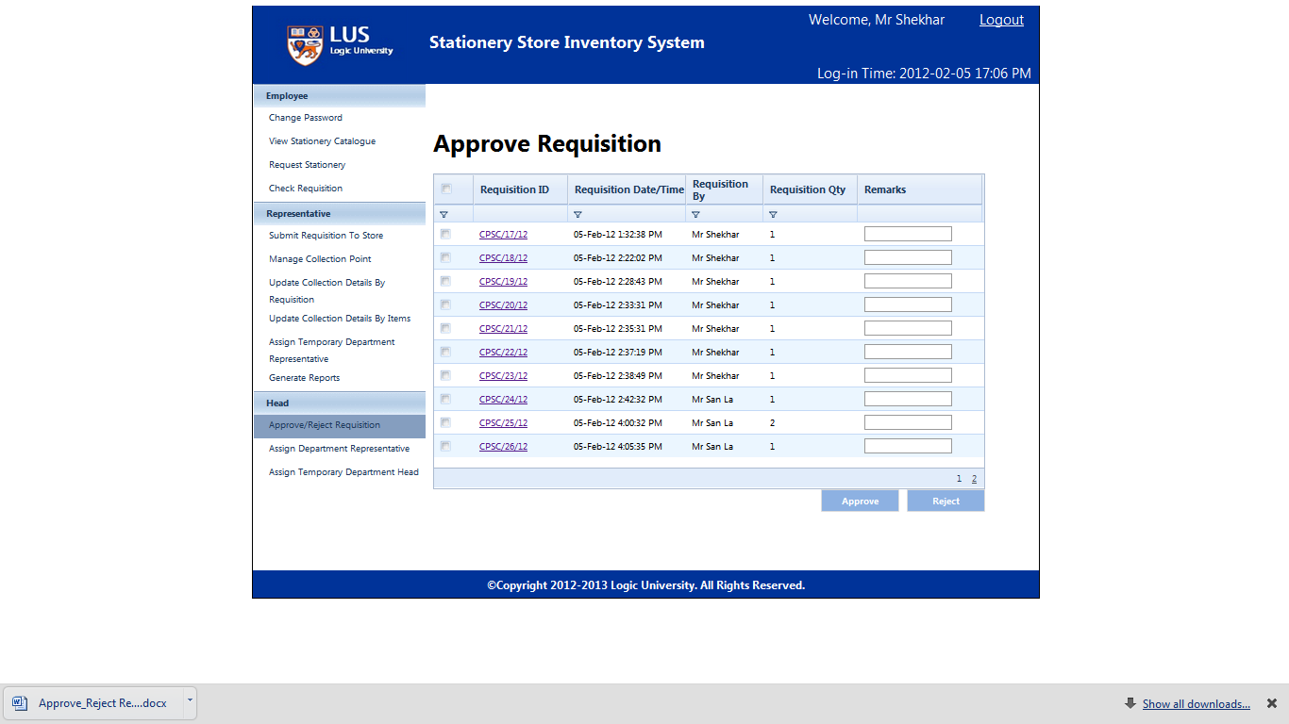

Click requisition id, head can view requisition detail.

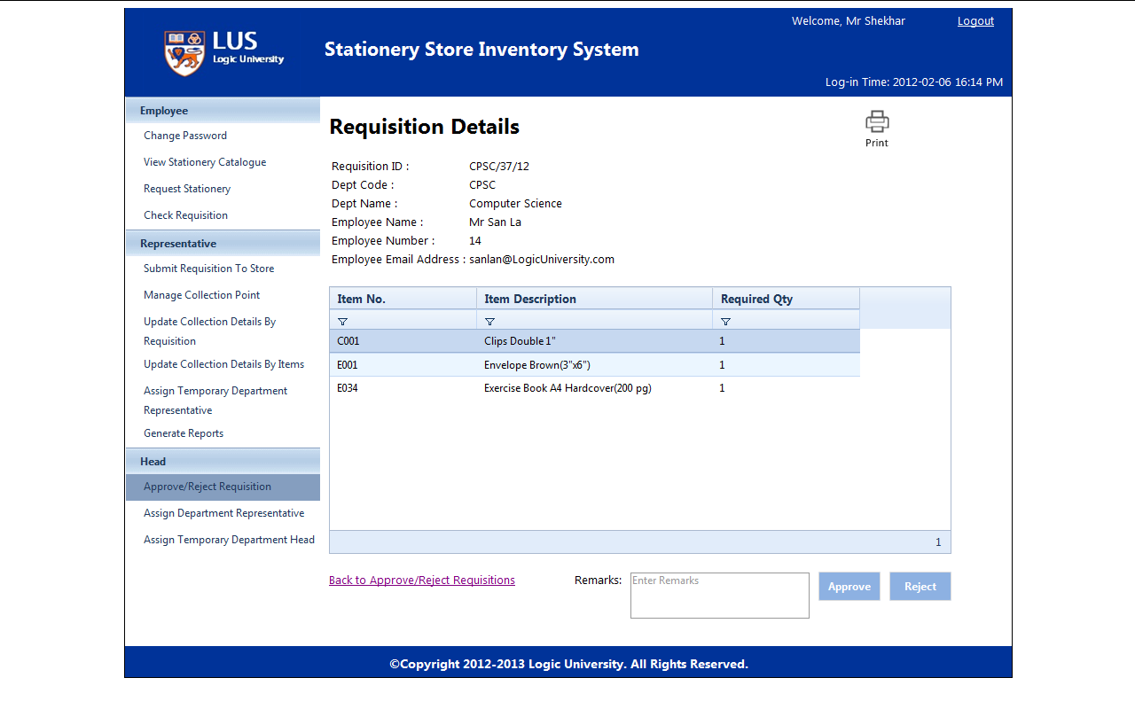

Head can modify required qty.

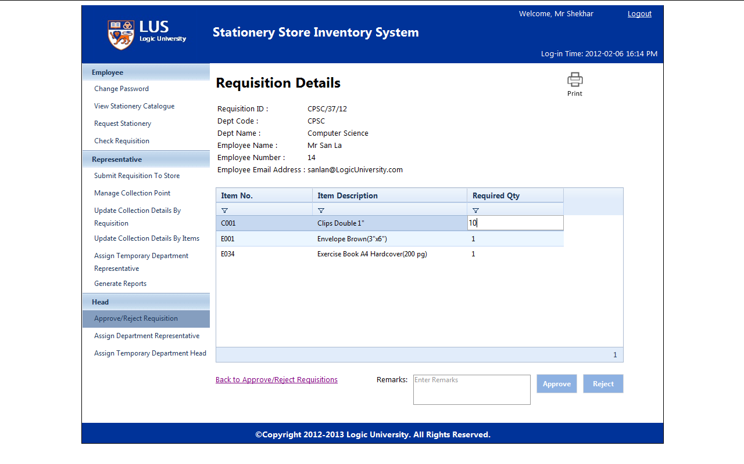

Head also can give remarks for approve or reject.

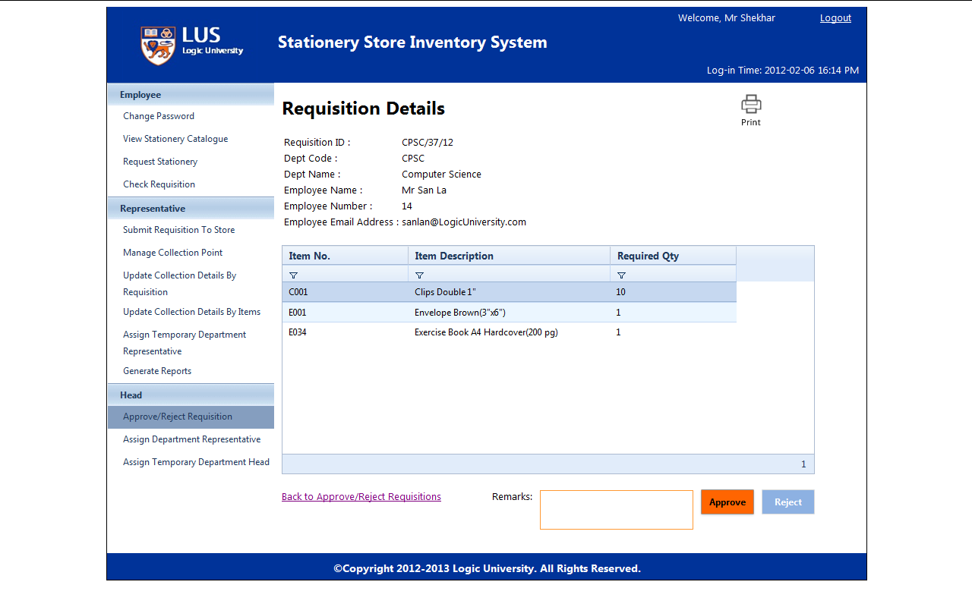

Click “Back to Approve/Reject Requisitions” link will go back to approve/reject requisition list screen.

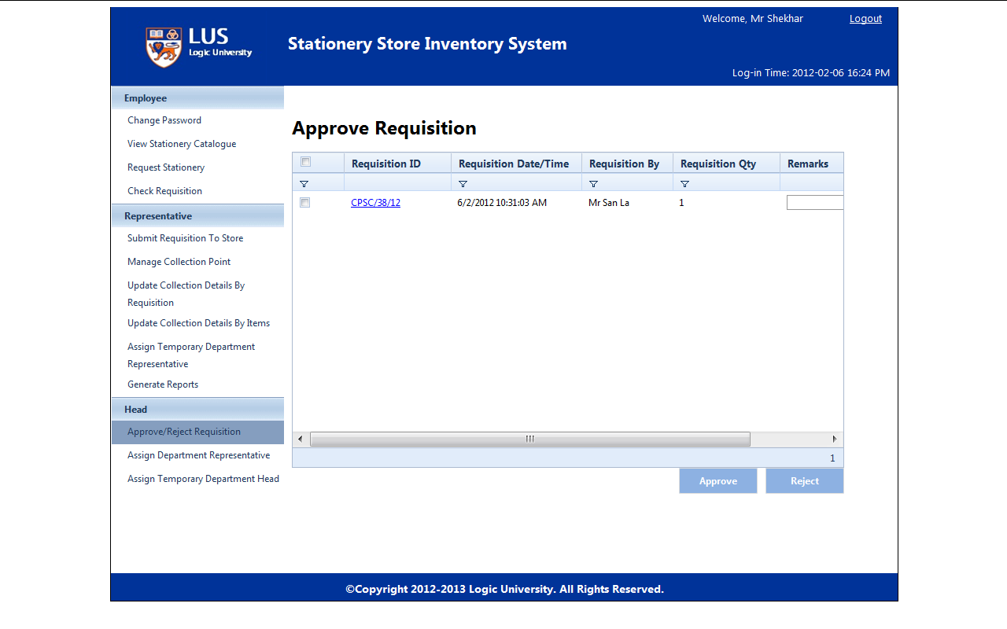

Click “Approve” then system will automatically send approved requisition to representative.



Before clicking “Approve” or “Reject”, user needs to select desire requisitions from the requisition list.

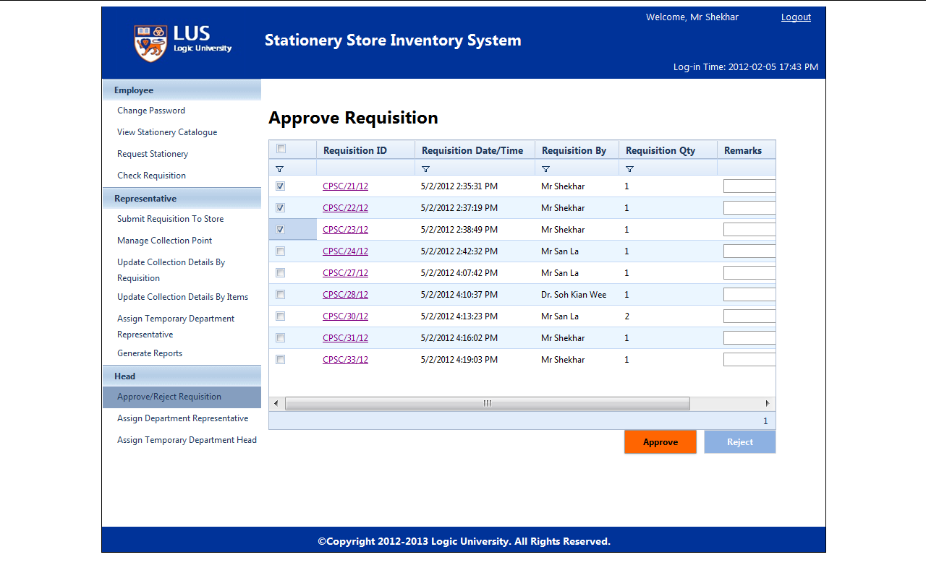

Clicking the check box from top left column will select all the requisitions.

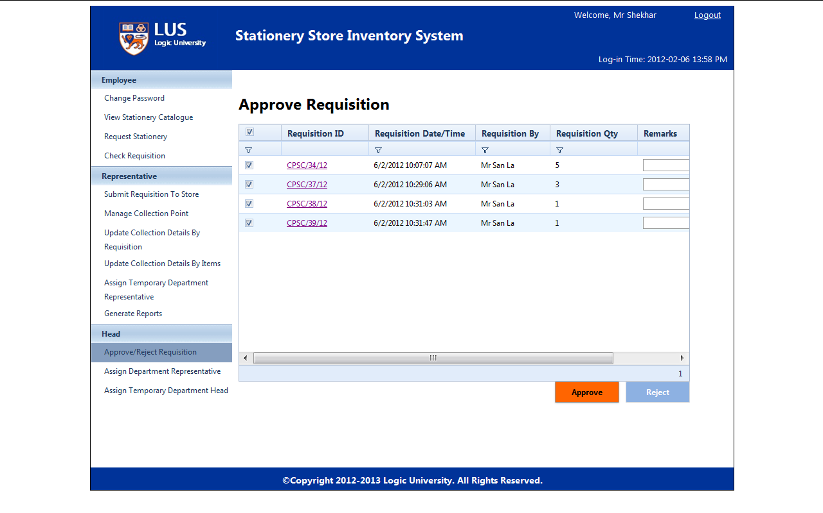

Click “Reject” to reject all the requisitions which have selected before.

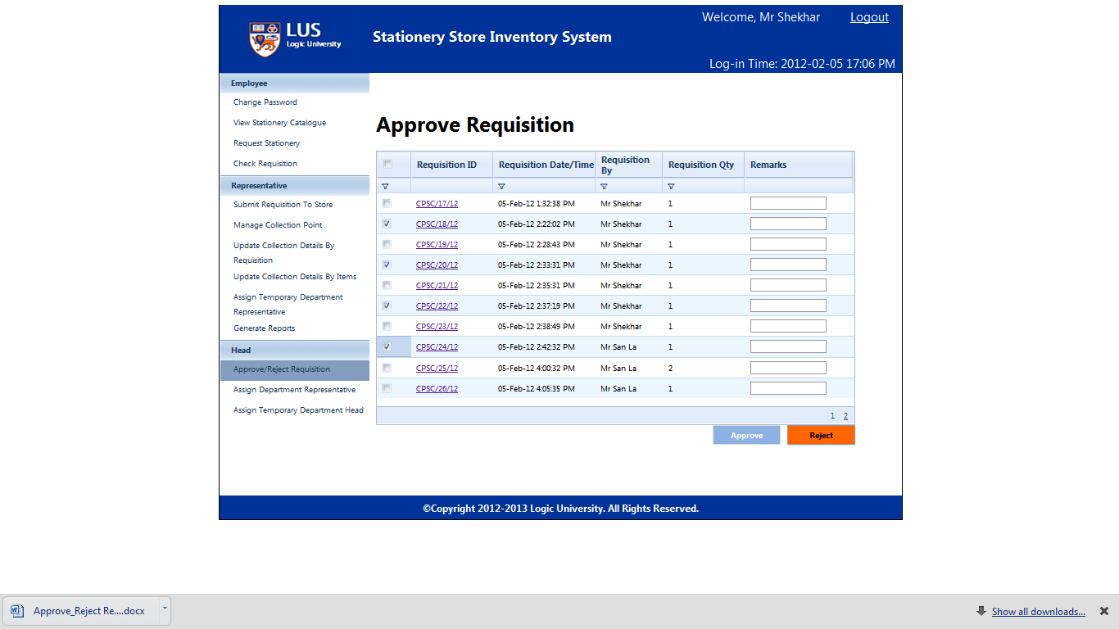

Department head can also give remarks before approve or reject.

